PATENT APPLICATION

Title of the Invention:
REAL-TIME COLLABORATIVE STUDY PLATFORM

Full Name | Nationality | Address
Vishwakarma Institute  of Technology | Indian | 666, Upper Indiranagar, Bibwewadi, Pune, Maharashtra, India – 411 037

Full Name | Nationality | VIIT Address | Email Id | Phone No.
Shadan Anwar | IN | Department of Computer Science & Engineering (Artificial Intelligence and Data Science), Vishwakarma Institute of Technology, Pune | shadan.22210072  @viit.ac.in | +91 9403308822
Rakshit Shah | IN | Department of Computer Science & Engineering (Artificial Intelligence and Data Science), Vishwakarma Institute of Technology, Pune | rakshit.22210035  @viit.ac.in | +91 8928921545
Vivek Ranalkar | IN | Department of Computer Science & Engineering (Artificial Intelligence and Data Science), Vishwakarma Institute of Technology, Pune | vivek.22210197  @viit.ac.in | +91 9579706521

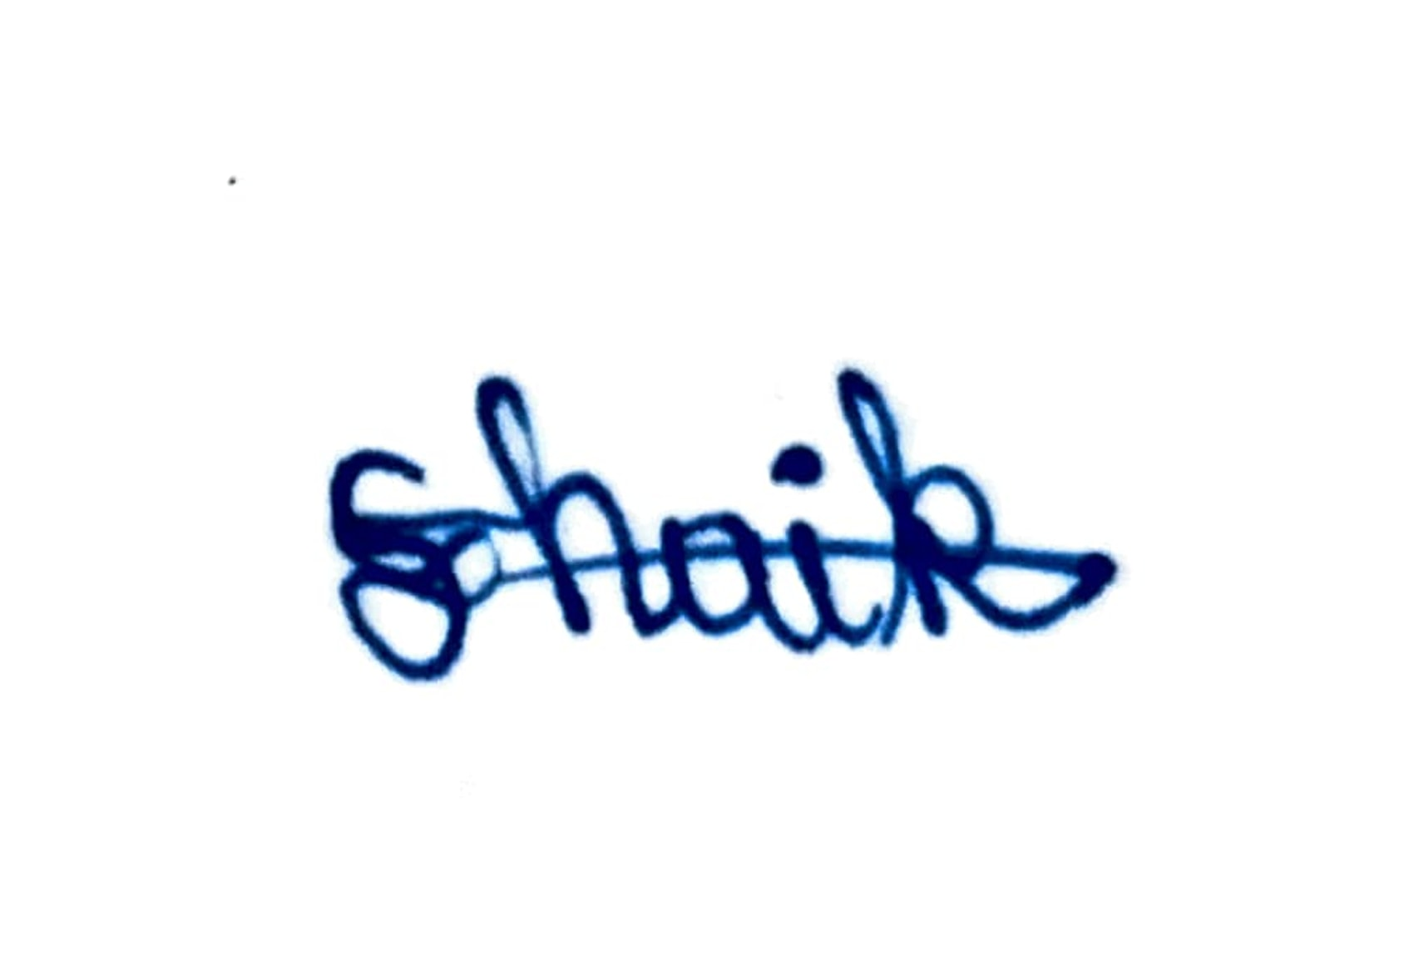 | 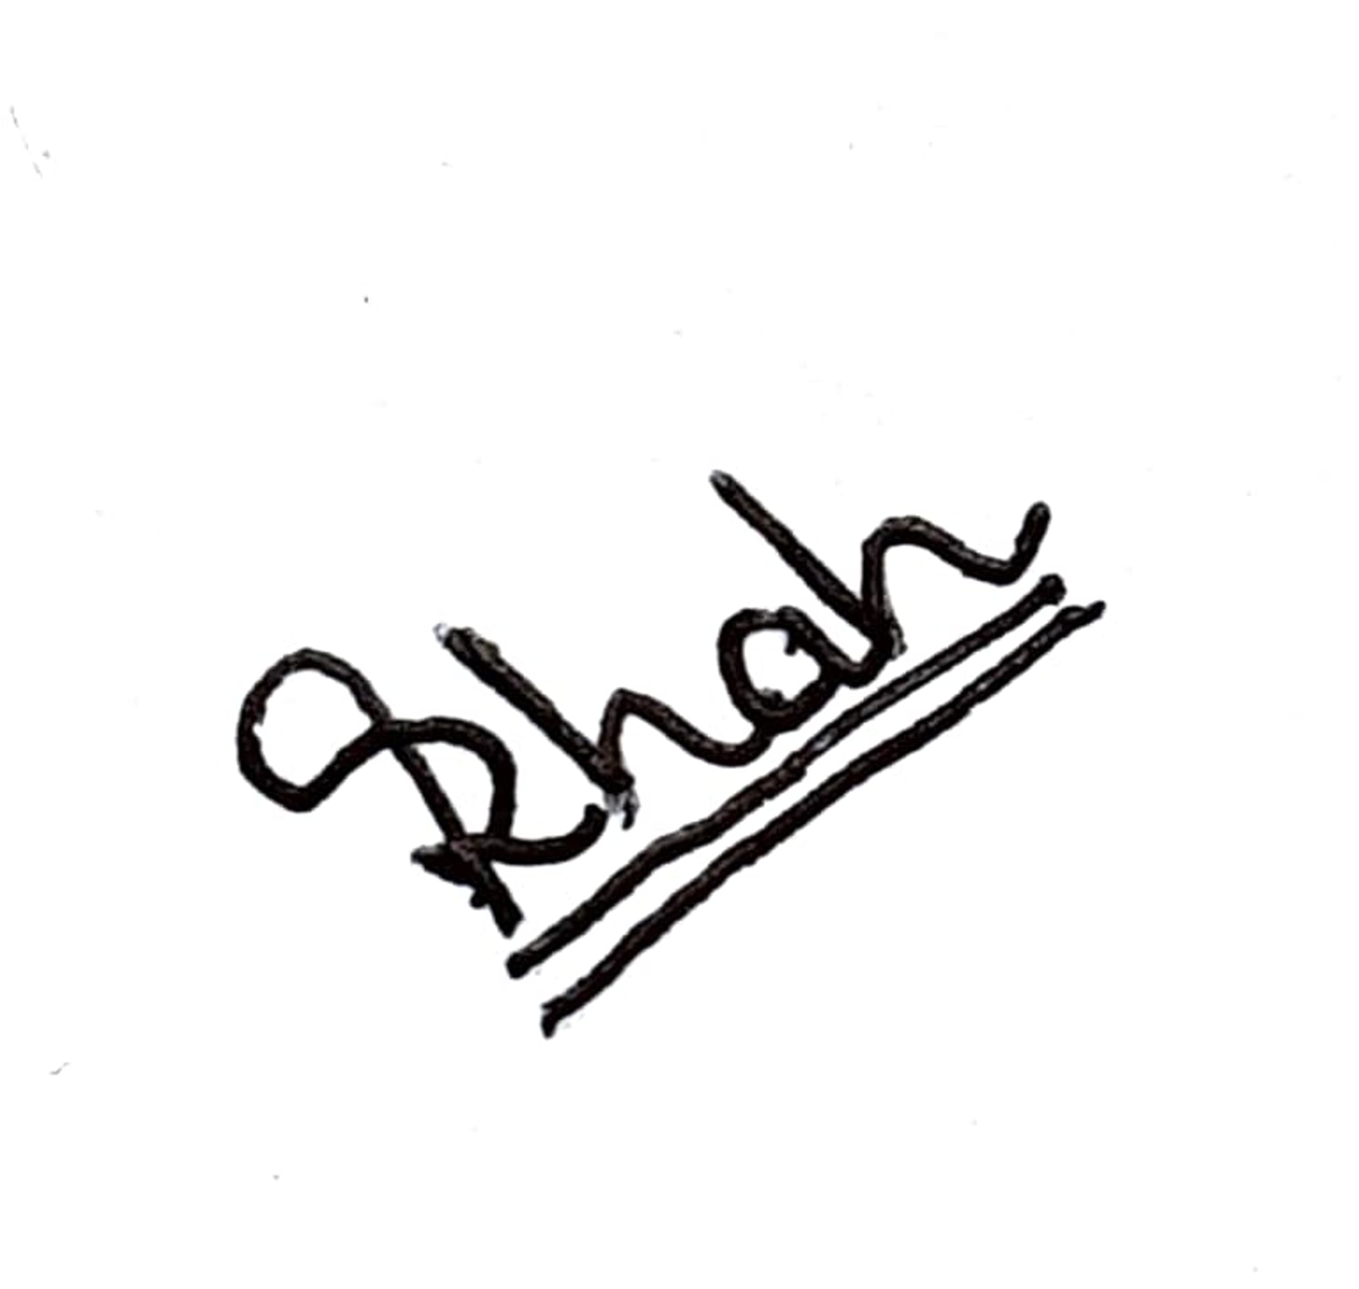 | 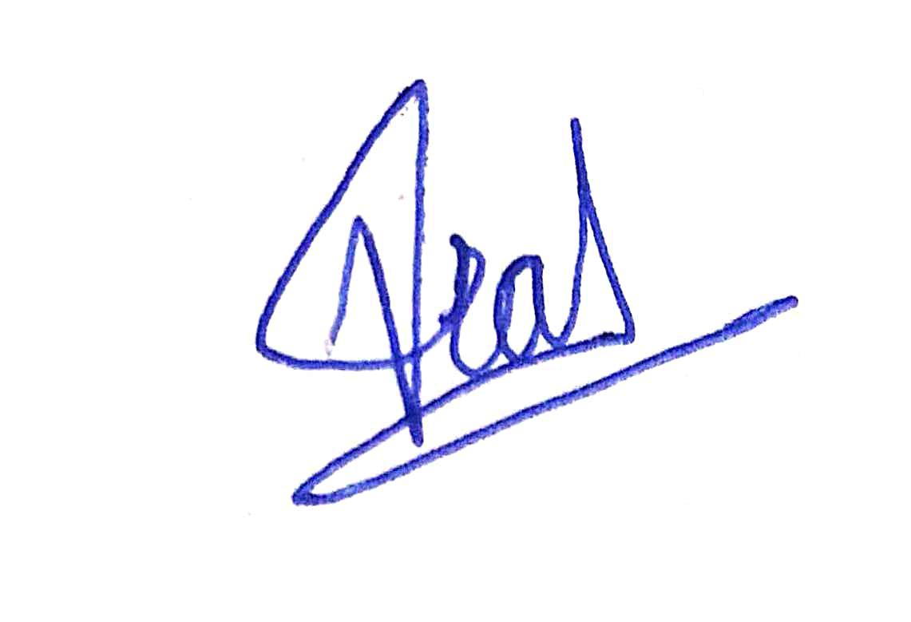
Shadan Anwar | Rakshit Shah | Vivek Ranalkar

1. TITLE OF THE INVENTION
REAL-TIME COLLABORATIVE STUDY PLATFORM
WITH INTEGRATED TASK MANAGEMENT AND ACTIVITY ANALYTICS

2. TECHNICAL FIELD OF THE INVENTION
The present invention pertains broadly to the domain of distributed computing and networked software systems. More specifically, it relates to the field of Human-Computer Interaction (HCI) and real-time groupware architectures. In its most particular aspect, the invention concerns a web-based, multi-user collaborative platform that unifies synchronous communication, structured task management, file-sharing, and participation analytics into a cohesive, single-session environment governed by HCI design principles.

3. BACKGROUND OF THE INVENTION
Contemporary academic and professional collaboration increasingly depends upon digital tooling. Students engaged in group assignments are compelled to simultaneously operate messaging platforms (e.g., WhatsApp, Telegram), document-editing suites (e.g., Google Docs, Microsoft 365), learning management systems (e.g., Moodle, Canvas), and file-storage services (e.g., Google Drive, Dropbox). This multi-tool paradigm gives rise to a constellation of well-documented inefficiencies:
- Fragmented Collaboration Ecosystem: Absence of interoperability among discrete tools necessitates repeated context-switching, increasing task-completion latency and introducing synchronisation errors across platforms.
- Absence of Unified Task Visibility: Existing LMS platforms provide rudimentary assignment submission features but lack integrated, real-time Kanban-style boards that reflect live progress to all group members simultaneously.
- Cognitive Overload: Concurrent management of multiple applications taxes working memory, diminishes focus, and elevates the probability of missed communications or overlooked assignments, as documented in the cognitive load literature.
- Asynchronous-Only or Synchronous-Only Tools: Tools such as email threads or shared document comments are inherently asynchronous. Dedicated chat applications, while synchronous, lack task-management and file-governance capabilities, forcing users to maintain parallel workflows.
- Weak Contribution Accountability: Existing platforms provide little or no quantitative tracking of individual member contributions — messages dispatched, tasks completed, or files uploaded — depriving team leads of actionable performance insights.
Attempts by prior platforms to address subsets of these problems have remained partial. The foregoing limitations collectively underscore the need for an integrated, HCI-informed system that subsumes all collaboration modalities within a single, coherent interface.

4. PRIOR ART
The following categories of prior art are relevant to the present invention:

4.1 Real-Time Document Co-Editing Systems
Systems such as Google Docs and Microsoft SharePoint Online enable concurrent document editing through Operational Transformation or Conflict-free Replicated Data Type (CRDT) algorithms. However, these systems are document-centric and do not provide room-scoped task boards, role-based member management, or integrated activity analytics. Their communication facilities are limited to comment threads rather than persistent, real-time chat streams.

4.2 Project Management Platforms
Platforms such as Trello, Asana, and Jira provide Kanban-style task boards and assignment tracking. These systems are designed for professional software development workflows and lack integrated real-time messaging, file sharing bounded to project rooms, or HCI-optimised interfaces for academic collaborative learning. They require separate communication tools (e.g., Slack integration) and do not provide a unified session workspace.

4.3 Learning Management Systems (LMS)
Systems such as Moodle, Canvas, and Blackboard provide course-level collaboration through discussion forums, assignment submission portals, and grade books. They do not support persistent, room-scoped real-time chat, drag-and-drop Kanban task management, or live participant-contribution analytics within a single session interface.

4.4 Team Communication Platforms
Platforms such as Slack and Microsoft Teams provide channel-based messaging with file attachment capabilities. While these include some task-management plug-ins, the integration is loose and not natively designed to enforce role-based access within bounded study rooms or to correlate communication activity with task-completion metrics in real time.

4.5 Gap Analysis
None of the foregoing prior-art systems present, within a single platform, all of the following capabilities: (i) persistent WebSocket-based real-time messaging bounded to room context, (ii) integrated Kanban task management with drag-and-drop state transitions, (iii) role-differentiated room membership, (iv) centralised file sharing within the room namespace, and (v) quantitative, per-member activity analytics — all governed by formally applied HCI principles including Norman's Action Model and Shneiderman's Eight Golden Rules. The present invention fills this gap.

5. OBJECT OF THE INVENTION
The primary and ancillary objects of the present invention are as follows:
- To provide a unified, web-based collaborative study platform that consolidates real-time communication, task management, file sharing, and activity monitoring within a single interface, thereby eliminating the need for multiple disparate tools.
- To implement a persistent, bidirectional WebSocket communication channel scoped to individual study rooms, enabling sub-100-millisecond latency message delivery without repeated HTTP polling.
- To provide a Kanban-style task management board supporting drag-and-drop state transitions across three canonical workflow states — To-Do, In Progress, and Done — with live synchronisation across all room participants.
- To implement role-based access control within study rooms, distinguishing administrator privileges (room creation, member management, task assignment) from standard member privileges.
- To furnish per-member activity analytics tracking discrete participation metrics — including message count, task completions, and file uploads — thereby supporting equitable contribution assessment.
- To design the user interface in accordance with established HCI principles, including the reduction of the Gulf of Execution and the Gulf of Evaluation, application of Norman's Seven-Stage Action Model, and adherence to Shneiderman's Eight Golden Rules of Interface Design.
- To achieve the foregoing objectives through a three-tier client-server architecture employing stateless REST APIs for persistent data operations and WebSocket channels for event-driven, real-time updates.
- To deliver a platform applicable across academic institutions, EdTech environments, and distributed professional teams without dependency on proprietary third-party collaboration services.

6. SYNOPSIS OF THE INVENTION
The present invention discloses a web-based, multi-user groupware system designated herein as a Unified Real-Time Collaborative Study Platform. The system operates on a three-tier client-server architecture comprising: (i) a Presentation Layer implemented in HTML5, CSS3 (Tailwind framework), and JavaScript; (ii) an Application Layer built upon a high-performance asynchronous REST framework (FastAPI); and (iii) a Data Layer persisting structured relational data.
Users authenticate via JSON Web Tokens (JWT) and are directed to a dashboard from which they may create or join bounded study rooms. Each room maintains: a persistent WebSocket connection for real-time broadcast of chat messages and task-state changes; a Kanban task board accessible to all room members; a file repository for centralised document storage and retrieval; and an activity panel displaying per-member participation statistics.
The system's communication architecture employs a hybrid model: HTTP REST endpoints govern create-read-update-delete (CRUD) operations against persistent state, while a single WebSocket channel per room propagates event notifications — including new messages, task transitions, and member join or leave events — to all connected clients with minimal latency. This design ensures both data durability and real-time responsiveness.

7. BRIEF DESCRIPTION OF THE DRAWINGS
The accompanying drawings, which are incorporated herein by reference, illustrate preferred embodiments of the invention and, together with the detailed description, serve to explain the principles of the invention.
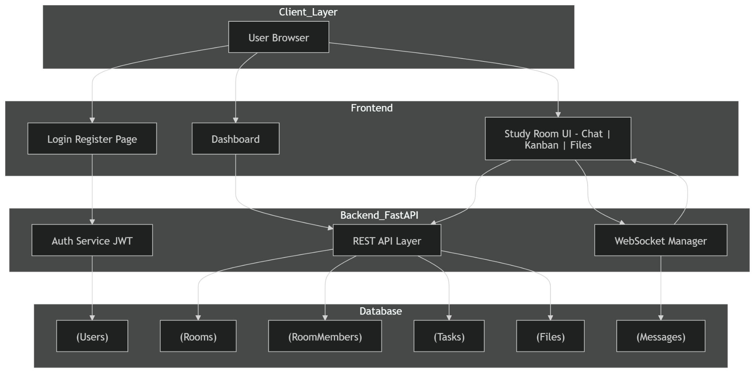

Figure 1 — System Architecture Diagram
- Client Browser (Presentation Layer)
- HTTP/REST Interface
- WebSocket Interface
- Application Server (FastAPI Backend)
- Authentication Module (JWT Engine)
- Room Management Module
- Task Management Module (Kanban Engine)
- Chat Broadcast Module
- File Management Module
- Activity Analytics Module
- Relational Database (SQLite / PostgreSQL)
- Local File Storage Repository

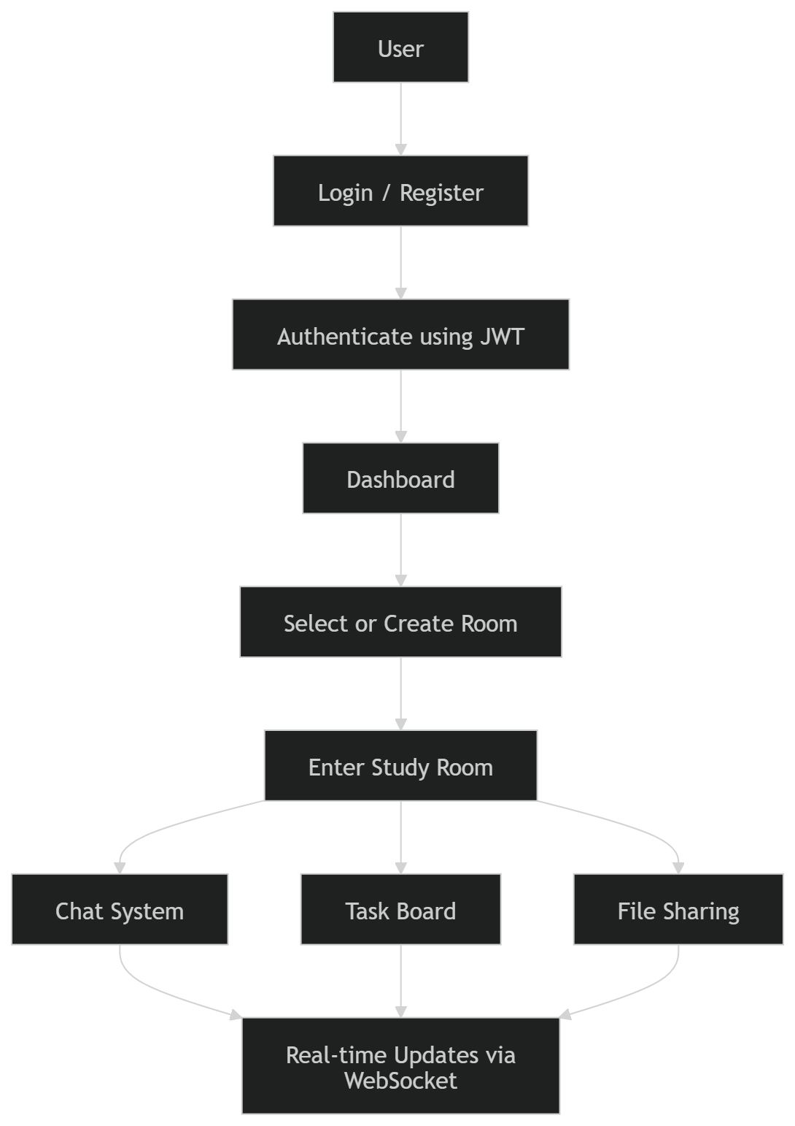

Figure 2 — Data Flow Diagram (User Session Lifecycle)
- User Authentication Request
- JWT Token Issuance
- Room Selection / Creation
- WebSocket Handshake and Connection Establishment
- Task Board State Synchronisation
- Real-Time Chat Message Broadcast
- File Upload / Download Transaction
- Activity Event Logging
- Analytics Aggregation and Display
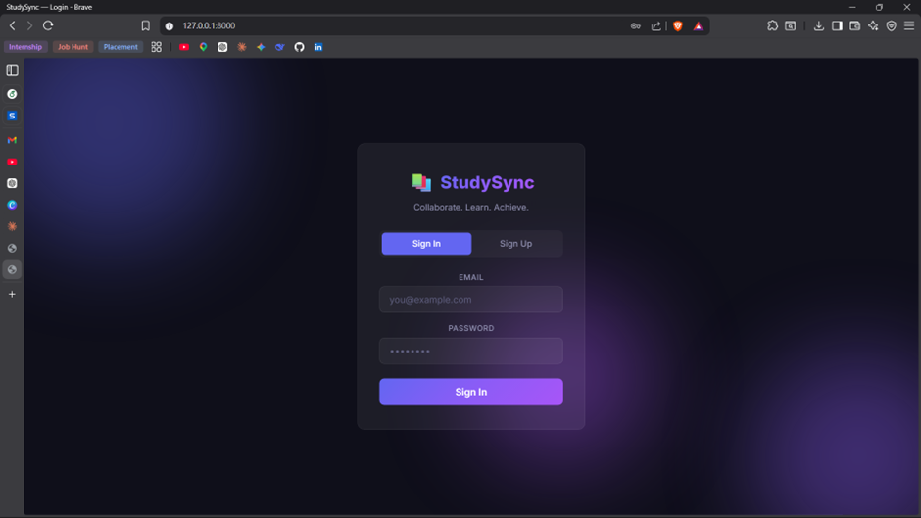

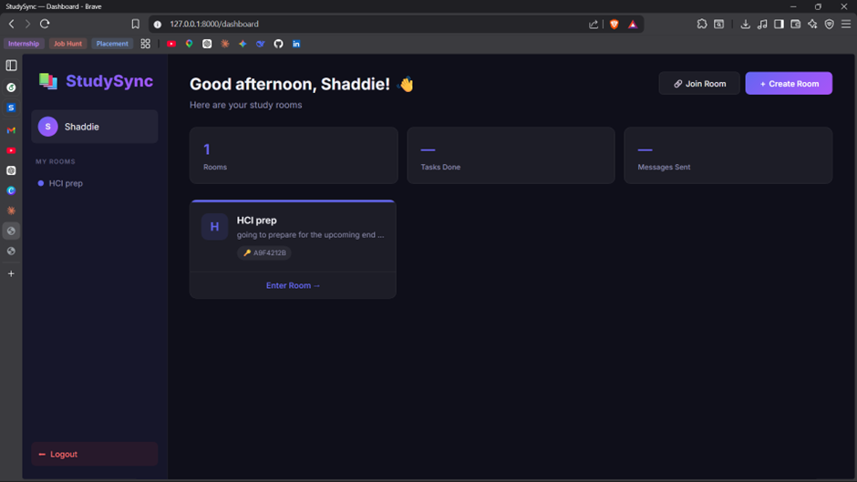
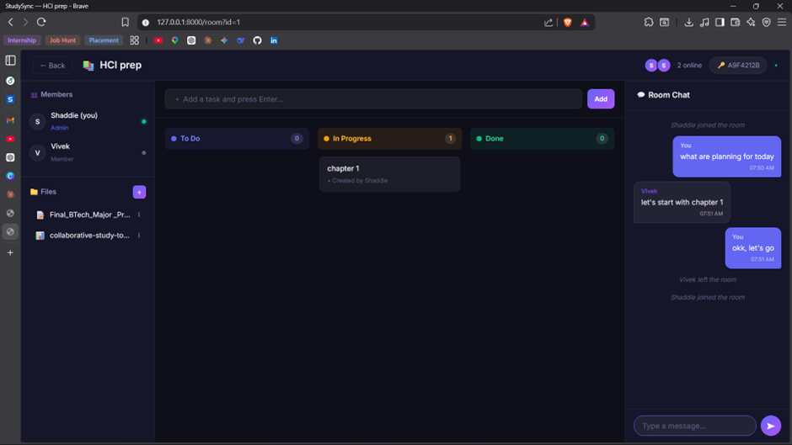

Figure 3 — User Interface Layout Diagram
- 301 — Login / Registration Screen
- 302 — Room Dashboard Panel
- 303 — Study Room Three-Panel View (Left: Members and Files; Centre: Kanban Task Board; Right: Real-Time Chat)
- 304 — Task Card Component with Drag-and-Drop Handle
- 305 — Activity Statistics Widget

8. DETAILED DESCRIPTION OF THE INVENTION
The following detailed description sets forth specific embodiments of the invention. This description is intended to be illustrative rather than limiting, and persons skilled in the relevant art will recognise that equivalent structures may be substituted without departing from the spirit and scope of the invention.

A. System Architecture
The system employs a three-tier architecture that enforces separation of concerns across three discrete layers:
- Presentation Layer (Tier 1): The client-side interface is rendered within standard web browsers and constructed using HTML5 markup, CSS utility classes provided by the Tailwind framework, and vanilla JavaScript. This tier is responsible for rendering all user-facing components — including the login interface, the room dashboard, and the three-panel study room view — and for initiating both HTTP requests and WebSocket connections to Tier 2.
- Application Layer (Tier 2): The server-side logic is implemented using FastAPI, an asynchronous Python web framework. This tier exposes a suite of REST API endpoints for CRUD operations and maintains a WebSocket connection manager that routes real-time events to all clients subscribed to a given room. Business logic — authentication, authorisation, task-state validation, and analytics aggregation — is executed exclusively within this layer.
- Data Layer (Tier 3): A normalised relational database stores all persistent entities: user accounts, room configurations, membership records, task definitions and state history, file metadata, and activity log entries. The system is engineered to operate with SQLite in development and PostgreSQL in production, with a data access abstraction layer enabling this substitution without modification to application logic.

B. Functional Modules
B.1 Authentication System
User identity is established through a registration-and-login flow. Upon successful credential verification, the Application Layer issues a signed JSON Web Token (JWT) containing the user's unique identifier and role claims. The JWT is transmitted to the client and appended to the Authorization header of all subsequent REST requests. Token expiration and refresh logic are managed server-side. Passwords are stored exclusively as salted hash digests; no plaintext credential persists in the Data Layer.
B.2 Room Management Module
Authenticated users may create a named study room, upon which they assume the Administrator role for that room. Any user possessing a valid room identifier may join as a Member. The room record in the Data Layer maintains a membership table recording each participant's role and join timestamp. The Administrator may modify room metadata, remove participants, and dissolve the room. Role-based access enforcement is applied by the Application Layer to every room-scoped API and WebSocket event.
B.3 Task Management System (Kanban Engine)
Each study room maintains a Kanban task board persisted in the Data Layer. Tasks are modelled as records comprising: title, optional description, assignee reference, creation timestamp, and current state. The canonical state enumeration comprises three values: TO_DO, IN_PROGRESS, and DONE. Task state transitions are executed by dragging the task card element in the Presentation Layer; the resulting state change is transmitted via REST PATCH to the Application Layer, which updates the Data Layer record and broadcasts a task-update event over the room's WebSocket channel, causing all connected clients to re-render their board without page reload.
B.4 Real-Time Chat System
Upon joining a room, the client establishes a persistent WebSocket connection to a room-specific endpoint managed by the Application Layer's WebSocket Connection Manager. Chat messages composed by a user are transmitted over this connection as JSON payloads containing the sender identifier, message body, and a server-assigned ISO 8601 timestamp. The Connection Manager immediately broadcasts the payload to all active subscribers of the room. Message records are persisted asynchronously to the Data Layer, enabling retrieval of conversation history upon reconnection. The WebSocket protocol eliminates repeated HTTP request overhead, achieving a measured end-to-end latency below 100 milliseconds under standard network conditions.
B.5 File Management System
The system supports upload, storage, and retrieval of documents within the room namespace. A client initiates a file upload via an HTTP multipart POST request. The Application Layer validates file type and size constraints, persists file binary data to a room-scoped directory in local storage, and records file metadata — including original filename, MIME type, uploader identity, and upload timestamp — in the Data Layer. Room members may list available files and initiate downloads through authenticated GET requests. File upload events are broadcast over the WebSocket channel to notify all room participants of newly available resources.

B.6 Activity Monitoring and Analytics Module
The Application Layer records a discrete event entry in the Data Layer for each of the following user actions: message transmitted, task state transition executed, and file uploaded. An analytics aggregation query computes per-member summaries of each event type for a specified room. These summaries are exposed via a REST endpoint and rendered in the Activity Statistics Widget (reference 305) within the Presentation Layer, providing team leads and members with quantitative visibility into individual contributions.

C. Communication Architecture
The system operates a dual-channel communication model:
- REST Channel: HTTP/1.1 or HTTP/2 endpoints handle stateful operations requiring transactional integrity — user registration, login, room creation and deletion, task creation and metadata update, and file operations. Each request carries a Bearer JWT token for authentication.
- WebSocket Channel: A single persistent WebSocket connection per room client handles all event-driven updates. The server-side Connection Manager maintains a registry of active connections indexed by room identifier. On receipt of any state-modifying event (chat message, task transition, file upload, member join/leave), the manager fans out the event payload to all registered connections for that room.

D. Data Flow and Working Logic
- 1The user navigates to the application URL. The Presentation Layer renders the Login Screen (reference 301).
- The user submits credentials. The Application Layer verifies against the Data Layer and returns a signed JWT.
- The Presentation Layer stores the JWT and renders the Room Dashboard (reference 302), populated via a REST GET request for the user's room memberships.
- The user creates or selects a room. The Application Layer creates or retrieves the room record and returns room metadata, member list, task board state, and file index.
- The Presentation Layer opens a WebSocket connection to the room endpoint and renders the three-panel Study Room view (reference 303).
- Task board state is fetched via REST GET and rendered in the Kanban panel. Subsequent task state changes are transmitted via REST PATCH and broadcast to all room members via WebSocket.
- Chat messages entered by the user are transmitted over the WebSocket connection and broadcast in real time to all room subscribers. Historical messages are fetched via REST GET on initial load.
- File uploads are executed via REST POST. Completion events are broadcast via WebSocket. Downloads are executed via authenticated REST GET.
- Activity events are logged in the Data Layer upon each action. Analytics are aggregated and served via REST GET on demand.

E. HCI Design Integration
The system's interface architecture is informed by formal HCI theory:
- Gulf of Execution: The interface exposes unambiguous affordances for all primary actions — labelled action buttons ('Create Room', 'Add Task', 'Send Message', 'Upload File') ensure that users can form accurate mental models of available operations without consulting documentation.
- Gulf of Evaluation: Immediate system-state feedback is provided after every action — task cards animate to their new column upon drag-drop completion; chat messages display delivery confirmation; file uploads render progress indicators and completion notifications.
- Norman's Seven-Stage Action Model: The interface is structured to support all seven stages — goal formation, plan specification, action sequence selection, action execution, perception of system state, interpretation of perceived state, and evaluation against the goal — with each stage supported by visual affordances and feedback elements.
- Shneiderman's Eight Golden Rules: The interface adheres to the principles of consistency across screens, informative feedback, clearly marked exits, error prevention through input validation, and progressive disclosure of complexity.
- Direct Manipulation: Task state transitions are achieved through drag-and-drop interaction, a direct manipulation paradigm that preserves the user's sense of spatial agency over the task board and reduces the cognitive distance between intention and effect.

9. BEST METHOD OF PERFORMANCE
The following describes the optimal operational sequence of the invention as implemented in its preferred embodiment:
- System Initialisation: The Application Layer server is launched, establishing database connections and initialising the WebSocket Connection Manager. The Presentation Layer is served as a static asset bundle to the client browser.
- User Registration and Authentication: A new user submits a registration form. The Application Layer hashes the password using an industry-standard one-way hashing algorithm, persists the account record, and returns a signed JWT with a configurable expiration window (preferred: 24 hours).
- Room Creation: The authenticated user submits a room name and optional description. The Application Layer creates the room record, assigns the Creator as Administrator, and returns the room identifier and initial state payload. The user is redirected to the Study Room view.
- Member Onboarding: Secondary users authenticate and navigate to the Room Dashboard. They enter the room identifier issued by the Administrator and submit a join request. The Application Layer creates a membership record with Member role and broadcasts a join event over the room's WebSocket channel.
- Task Assignment: The Administrator or authorised Member creates a task by specifying title, description, and assignee. The task is created in TO_DO state. The assignee and all room members receive a WebSocket broadcast notifying them of the new task.
- Collaborative Communication: Members compose and transmit chat messages in the right panel. Each message is broadcast in real time to all subscribers, achieving effective synchronous group communication within the room context.
- File Distribution: A member uploads a study resource (PDF, presentation, or document). The file is stored in the room repository and an upload-completion event is broadcast. All members may subsequently retrieve the file via the file panel.
- Task Progression: Members drag task cards across the Kanban columns as work progresses. Each state transition is persisted and broadcast, maintaining a live shared view of group progress.
- Activity Review: At any point, members access the Activity Statistics Widget to review per-member contribution metrics. The Administrator may use these metrics to balance workload distribution or evaluate participation equity.
- Session Termination: The user closes the browser tab or explicitly logs out. The WebSocket connection is gracefully closed; the server updates the member's last-active timestamp.

Practical Example: In a five-member study group preparing a university-level project submission, the group Administrator creates a room titled 'Database Project Sprint 1'. Four tasks are created and assigned to individual members. Over a two-hour session, members exchange 80 chat messages, complete three tasks by dragging cards from IN_PROGRESS to DONE, and upload four reference documents. The Activity Widget displays each member's contribution count, enabling the Administrator to identify and re-engage a member with zero recorded interactions.

10. CLAIMS
What is claimed is:

Claim 1. A computer-implemented system for real-time multi-user collaborative study, the system comprising: a Presentation Layer executing within a client web browser and comprising a unified three-panel study room interface; an Application Layer comprising an asynchronous server process that exposes REST API endpoints for persistent data operations and a WebSocket Connection Manager for event-driven real-time communication; a Data Layer comprising a normalised relational database storing user accounts, room configurations, membership records, task state data, file metadata, and activity event logs; a Room Management Module operative to create bounded study rooms, assign role-based access privileges comprising at minimum an Administrator role and a Member role, and maintain a membership registry; a Task Management Module comprising a Kanban engine operative to create, assign, and transition task records between a plurality of workflow states and to broadcast state-transition events to all room subscribers via the WebSocket Connection Manager; a Real-Time Chat Module operative to receive chat message payloads over a persistent WebSocket connection and broadcast said payloads to all active WebSocket connections registered for the same room; a File Management Module operative to receive file upload requests via HTTP multipart POST, store file binary data in a room-scoped repository, persist file metadata in the Data Layer, and broadcast upload-completion events via the WebSocket Connection Manager; and an Activity Analytics Module operative to record discrete participation events for each user action and aggregate per-member contribution metrics for display within the Presentation Layer.
Claim 2. The system as claimed in Claim 1, wherein the WebSocket Connection Manager maintains a registry of active client connections indexed by room identifier and, upon receipt of any state-modifying event, performs a fan-out broadcast of the event payload to all connections registered under the corresponding room identifier.
Claim 3. The system as claimed in Claim 1, wherein the Authentication System issues a cryptographically signed JSON Web Token (JWT) upon successful credential verification, and wherein said token is transmitted as a Bearer token in the Authorization header of all subsequent REST API requests to enforce stateless authentication.
Claim 4. The system as claimed in Claim 1, wherein the Kanban engine supports at minimum three discrete task workflow states comprising a first state corresponding to work not yet commenced, a second state corresponding to work in active progress, and a third state corresponding to completed work, and wherein transitions between said states are effected through direct drag-and-drop manipulation within the Presentation Layer.
Claim 5. The system as claimed in Claim 4, wherein a task state transition initiated in the Presentation Layer is transmitted to the Application Layer via a REST PATCH request, the Application Layer updates the task record in the Data Layer, and the WebSocket Connection Manager broadcasts the updated task state to all room subscribers, causing all connected clients to re-render the Kanban board without requiring a full page reload.
Claim 6. The system as claimed in Claim 1, wherein the three-panel study room interface of the Presentation Layer comprises a left panel displaying room member roster and file repository, a central panel displaying the Kanban task board, and a right panel displaying the real-time chat stream, and wherein all three panels are rendered and updated within a single browser session without navigation to separate pages.
Claim 7. The system as claimed in Claim 1, wherein the Activity Analytics Module records a discrete event log entry in the Data Layer for each of the following user-initiated actions: transmission of a chat message, execution of a task state transition, and upload of a file to the room repository; and wherein an aggregation query over said event log produces per-member participation summaries comprising at minimum message count, task transition count, and file upload count.
Claim 8. The system as claimed in Claim 1, wherein the user interface of the Presentation Layer is designed in accordance with the following Human-Computer Interaction principles: reduction of the Gulf of Execution through explicit labelled affordances for all primary actions; reduction of the Gulf of Evaluation through immediate visual feedback following every user action; and application of Norman's Seven-Stage Action Model to structure the interaction flow from goal formation to outcome evaluation.
Claim 9. The system as claimed in Claim 1, wherein the Application Layer is implemented using an asynchronous web framework supporting concurrent request handling without thread-per-request overhead, enabling the system to maintain a plurality of simultaneous WebSocket connections without degradation of REST endpoint responsiveness.
Claim 10. The system as claimed in Claim 1, wherein the Data Layer is implemented using a relational database management system and wherein the system's data access abstraction layer permits substitution of the underlying database engine between a first lightweight single-file database engine suitable for development environments and a second full-featured database engine suitable for production deployment without modification to application logic.
Claim 11. The system as claimed in Claim 1, wherein the Room Management Module enforces role-based access control such that: an Administrator possesses privileges to create and dissolve rooms, add and remove members, and create and delete any task; and a Member possesses privileges to create and update tasks within their assignment scope, transmit chat messages, upload and download files, and view activity statistics.
Claim 12. A method for providing unified real-time collaborative study facilitation, the method comprising: receiving and authenticating user credentials and issuing a session token; establishing a bounded study room associated with the authenticated user as Administrator; accepting join requests from secondary users and recording their membership under a Member role; establishing a persistent bidirectional WebSocket connection per room for each connected client; transmitting task creation and assignment data via REST API and persisting task records in a relational data store; broadcasting task state-transition events over the WebSocket channel to all room subscribers upon each drag-and-drop state change effected by any room member; receiving and broadcasting chat messages in real time over the room-scoped WebSocket channel; receiving file uploads via HTTP, storing file binary data in a room-scoped repository, and broadcasting upload-completion events; recording discrete activity event log entries for each user action; and aggregating per-member activity metrics and presenting said metrics within the unified interface.

11. INVENTIVE STEP
The present invention satisfies the requirement of an inventive step (non-obviousness) for the following reasons:

11.1 Unified Integration of Previously Fragmented Modalities
While individual prior-art components — real-time messaging, Kanban task management, file sharing, and activity analytics — exist as discrete commercial products, no prior system or obvious combination thereof consolidates all four modalities within a single, HCI-governed, room-scoped session interface. The cognitive and technical challenges involved in designing a coherent unified interface — ensuring that simultaneous updates to chat, task board, and file panel do not produce conflicting UI states — constitute a non-trivial engineering contribution.

11.2 Hybrid REST/WebSocket Architecture with Room-Scoped Fan-Out
The system's communication architecture departs from simple polling-based or exclusively REST-based designs. The decision to employ a hybrid model — REST for durable writes and a single room-scoped WebSocket with fan-out broadcast for ephemeral real-time events — required a non-obvious architectural decision to avoid connection-per-feature proliferation while ensuring that task, chat, and file events all propagate over the same channel without multiplexing conflicts.

11.3 HCI Principle Formalisation in System Design
The explicit, documented application of Norman's Action Model and Shneiderman's Eight Golden Rules as architectural requirements — rather than as post-hoc evaluation criteria — constitutes an inventive design methodology. Specifically, the reduction of the Gulf of Execution through affordance-driven UI components and the Gulf of Evaluation through event-driven immediate feedback are non-obvious design choices that required deliberate departure from conventional UI patterns employed by existing collaboration tools.

11.4 Drag-and-Drop Task Transition with Real-Time Multi-Client Synchronisation
The combination of direct drag-and-drop manipulation (a HCI direct-manipulation paradigm) with immediate multi-client WebSocket broadcast of the resulting state change — such that all connected room members observe the Kanban board update without any manual refresh — is a non-obvious integration that produces a qualitatively superior collaborative experience compared to polling-based Kanban implementations in prior art.

11.5 Activity Analytics Bounded to Room Context
The Activity Analytics Module's design — logging discrete events per action type, bounded by room identifier, and aggregating in real time per member — provides a granularity of contribution visibility not present in prior art systems. The correlation of chat activity, task transitions, and file operations into a single per-user contribution index within a room session is a non-obvious analytical design choice.

12. INDUSTRIAL APPLICATION
The present invention is industrially applicable and capable of deployment in a plurality of commercially and institutionally significant contexts:
- Academic Institutions: Universities, colleges, and secondary educational institutions may deploy the system to support structured group project collaboration, replacing ad hoc combinations of messaging applications and document editors with an auditable, role-governed platform. The activity analytics feature supports faculty-supervised peer-assessment workflows.
- EdTech Platforms: Online learning platforms offering team-based courses or project-based learning tracks may integrate the system as a collaboration module, providing learners with a purpose-built environment for synchronous and asynchronous group work.
- Remote and Hybrid Professional Teams: Small to medium-sized professional teams engaged in iterative project delivery may deploy the system as a lightweight alternative to enterprise project management suites, benefiting from its unified interface and low infrastructure overhead.
- Corporate Training Environments: Human resources departments and training providers conducting cohort-based learning programmes may deploy the system to facilitate structured group exercises, enabling trainers to monitor participant engagement through the activity analytics dashboard.
- Research Collaboration: Academic research groups requiring a shared workspace for literature management, task assignment, and real-time discussion may deploy the system as an integrated alternative to disparate communication and file management tools.
The system requires only a standards-compliant web browser on the client side and a server capable of executing the Application Layer process, rendering it deployable on commodity infrastructure without proprietary hardware dependencies. These characteristics confirm the invention's readiness for immediate industrial exploitation.

13. ABSTRACT
A unified real-time collaborative study platform is disclosed comprising a three-tier client-server architecture in which a browser-based Presentation Layer, an asynchronous Application Layer, and a normalised relational Data Layer cooperate to deliver consolidated collaboration services within a single session interface. The system provides: JSON Web Token authenticated user sessions; role-differentiated (Administrator and Member) bounded study rooms; a Kanban task management board with drag-and-drop state transitions broadcast in real time to all room participants via a room-scoped WebSocket channel; persistent real-time group chat with sub-100-millisecond latency; centralised file upload, storage, and retrieval bounded to the room namespace; and a per-member activity analytics module aggregating discrete participation events into quantitative contribution metrics. The interface is designed in strict accordance with established Human-Computer Interaction principles including Norman's Action Model, Shneiderman's Eight Golden Rules, and direct manipulation paradigms, thereby minimising cognitive load, reducing the Gulf of Execution, and providing immediate evaluative feedback after every user action. The invention eliminates the cognitive overhead of managing multiple fragmented collaboration tools, enhances group task visibility and accountability, and is applicable across academic, EdTech, and professional collaborative environments.

14. DRAWINGS
The following drawings are submitted as part of this patent application. Each drawing is incorporated herein by reference and forms an integral part of the disclosure:
- Figure 1: System Architecture Diagram — illustrating the three-tier architecture comprising the Presentation Layer (101), REST Interface (102), WebSocket Interface (103), Application Server (104), functional modules (105–110), Relational Database (111), and File Storage Repository (112).
- Figure 2: Data Flow Diagram — illustrating the user session lifecycle from authentication (201–202) through room onboarding (203–204), task synchronisation (205), real-time chat (206), file operations (207), activity logging (208), and analytics display (209).
- Figure 3: User Interface Layout Diagram — illustrating the Login Screen (301), Room Dashboard Panel (302), Study Room three-panel view (303), Task Card component with drag-and-drop handle (304), and Activity Statistics Widget (305).

